# Residual Current Devices

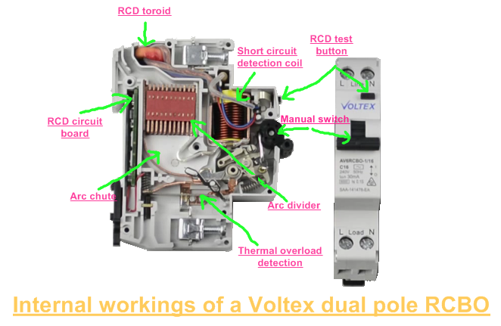The RCD is an electrical safety device that quickly and automatically breaks an electrical circuit to prevent you from getting a fatal electric shock if you touch something live. It also helps in reducing the risk of electrical fires caused by earth faults. RCDs offer a level of personal protection that ordinary fuses and circuit-breakers cannot provide, Due to its high sensitivity.

## Theory of operation

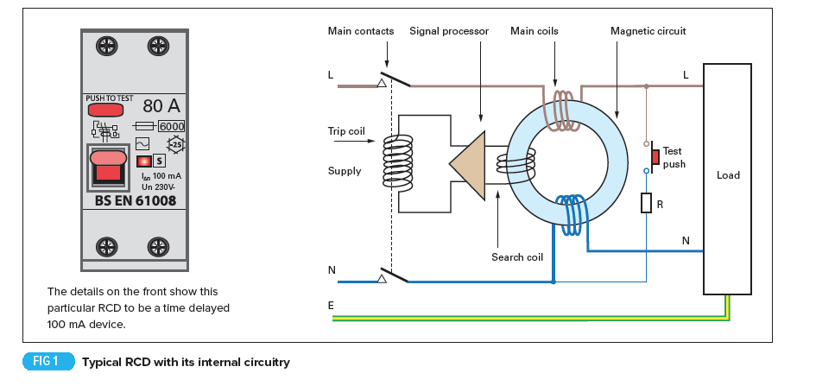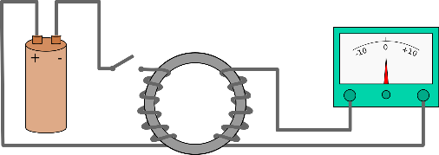It has a very simple working principle based on [Kirchhoff’s Current Law](https://www.electrical4u.com/kirchhoff-current-law-and-kirchhoff-voltage-law/) where the incoming [current](https://www.electrical4u.com/electric-current-and-theory-of-electricity/) in a circuit must be equal to the outgoing current from that circuit. This current is detected by Faraday’s Law of Induction which describes how an electric current produces a magnetic field and, conversely, how a changing magnetic field generates an electric current in a conductor.

RCDs use toroid core upon which the load current (live) and return current (neutral) conductors are wound in opposite directions, along with a detecting winding. In absence of an earth fault, the theoretical sum of the currents is equal to zero. In the presence of an earth fault, there is a difference between the load and return currents which generates a resultant flux in the toroid and induces a current in the detecting winding.

The detecting winding’s current operates a relay which opens the main contacts of the RCD. The tripping mechanism is operated using two alternative methods (Electromagnetic & Electronic), both offer very reliable performance. Electromagnetic devices use a very sensitive toroid, which operates the trip relay when it detects very small residual currents. Electronic devices do not need such a sensitive toroid as electronic circuits within the device amplify the signal to operate the trip relay.

## Types

RCDs can help protect you from electric shock in potentially dangerous areas and there are various types of RCDs that can be used to make sure you are always as safe as possible.

### RCCB (Residual Current Circuit Breaker)

The **RCCB** detects a current difference between the live and neutral conductors.  This current is known as a residual current. Correctly functioning circuits will always have balanced live and neutral currents. Residual currents are present when there is a fault or potential shock hazard. The current imbalance is usually detected by directing the current path for both the live and neutral conductors to wrap around a toroidal transformer contained within the RCCB body.  The generated magnetic flux is directly proportional to the current drawn through either the live or neutral conductors. The windings are constructed so the live and neutral currents induce magnetic fields in opposite directions. The balanced magnetic fields cancel each other out, making a net zero magnetic flux within the toroid. A small difference in current will result in a net magnetic flux greater than zero. When the net flux is proportional to the leakage current trigger point, the unit will trip out.

### RCBO (Residual Current Breaker with Overload)

It is a combination of a residual current device and a miniature circuit breaker in one package. When a current leakage fault occurs, the internal residual current detecting element will trip the whole circuit. Also, if the circuit is overloaded the internal thermal or magnetic circuit breaker parts are able to trip the circuit in the same way.

### ELCB (Earth Leakage Circuit Breaker)

ELCB is a voltage operated type. It was used to detect any voltage difference between the earth and neutral, indicating that there was a current flowing into the earth being monitored. Voltage ELCBs were widely used in the past and many are still in operation but are no longer used in new installations.

## Sensitivity

RCDs have a wide range of operation. For every RCD there is normally a choice of residual current sensitivity (tripping current). This defines the level of protection afforded.

* High sensitivity: 5, 10, 30 mA (for direct-contact or life injury protection),
* Medium sensitivity: 100, 300, 500, 1000 mA (for fire protection),
* Low sensitivity: 3, 10, 30 A (typically for protection of machine).

As the sensitivity of RCDs increases their cost accordingly increases.

## Limitations

RCDs will not protect against all instances of electric shock. If a person comes into contact with both the live and neutral conductors while handling faulty parts of an electrical installation, this contact will not be detected by the RCD unless there is a contact between the person and the ground, as some current may still pass through the person’s body to earth. RCDs cannot detect overload conditions, phase-to-neutral short circuits, phase-to-phase short circuits or loss of PEN conductor in TN-C systems. In these cases, over-current protection devices (fuses or circuit breakers) must be provided.

## Importance in electrical circuits

RCDs should operate within 25–40 milliseconds with any leakage currents (through a person) of greater than 30 mA, before electric shock can drive the heart into [ventricular fibrillation](https://en.wikipedia.org/wiki/Ventricular_fibrillation) (the most common cause of death through electric shock).

## Applications

RCDs are used for protection against direct and indirect contacts. They are used in many different installations that require protection such as: Construction sites, Agricultural and horticultural premises, Conducting locations with restricted movement, Caravan and camping parks, Exhibition shows and stands, Outdoor lighting, Marinas, Medical locations, Solar Photovoltaic system power supplies, Mobile or transportable units, Electric vehicle charging installations, Floor and ceiling heating systems.

## Selection Tables

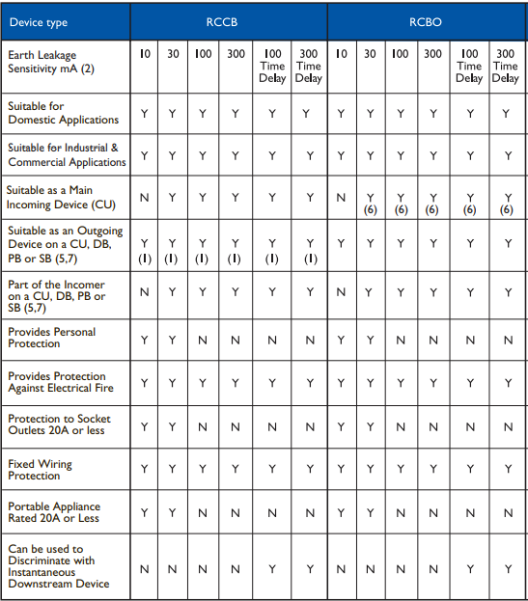



## Installation Types

There are various types of RCDs that can be used to ensure person’s safety.

### Fixed RCDs

These are installed in the [consumer unit (fuse box)](https://www.electricalsafetyfirst.org.uk/guidance/safety-around-the-home/fuseboxes-explained/) and can provide protection to individual or groups of circuits. A fixed RCD provides the highest level of protection as it protects all the wiring and the sockets in a circuit, and any connected appliances.

### Socket-Outlet RCDs

These are special socket-outlets with an RCD built into them which can be used in place of a standard socket-outlet. This type of RCD provides protection only to the person in contact with equipment, including its lead, plugged into the special socket-outlet.

### Portable RCDs

These plug into any standard socket-outlet. An appliance can then be plugged into the RCD. They are useful when neither fixed nor socket-outlet RCDs are available but, as with socket-outlet RCDs, they provide protection only to the person in contact with the equipment, including its lead, plugged into the portable RCD.

## Installation considerations

* To check installations, including the functioning of the RCD, during commissioning.
* To regularly verify installations, electrical loads and electrical equipment including RCD equipment during the installation life and to replace failing loads and electrical equipment including RCDs.
* To consider replacing loads or equipment, including RCDs, after a certain number of years depending on the conditions of use or installation.

# References

* <https://ieeexplore.ieee.org/abstract/document/1351184>
* <https://www.sciencedirect.com/topics/engineering/residual-current-device>
* <https://www.voltimum.co.uk/articles/rcds-and-18th-edition>
* <https://professional-electrician.com/18th-edition/rcds-operation-application-explained/>
* <https://www.electrical4u.com/residual-current-circuit-breaker/>
* <https://www.electricalengineeringtoolbox.com/2016/01/how-residual-current-device-rcd-works.html>